Lab Manual CS403P – Database Management Systems (Practical)


Lab No. | Lab Topic | Page No.
1 | Lab 1: Installation of Microsoft SQL Server | 2
2 | Lab 2: Context Level DFD (Data Flow Diagram) | 23
3 | Lab 3: Entity Relationship Diagram | 25
4 | Lab 4: Super type and subtype in the ERD (Entity Relationship Diagram) | 27
5 | Lab 5: Relational Database | 28
6 | Lab 6: ERD to RDM | 29
7 | Lab 7: Relational Algebra Operations | 30
8 | Lab 8: Normalization (2NF) | 33
9 | Lab 9: Normalization (3NF) | 36
10 | Lab 10: SQL Queries (Create and Insert) | 38
11 | Lab 11: SQL Queries | 40
12 | Lab 12: SQL Queries (Select, Group By and Having clause) | 43
13 | Lab 13: Joins | 45
14 | Lab 14: Indexes | 47
15 | Lab 15: Views | 49
16 | Lab 16: Views (Continued) | 50

Lab 1
Lab Title: Installation of Microsoft SQL Server

Problem Statement

You are required to install any version of Microsoft SQL Server in your system according to your system and operating system requirements.
Installation Steps:
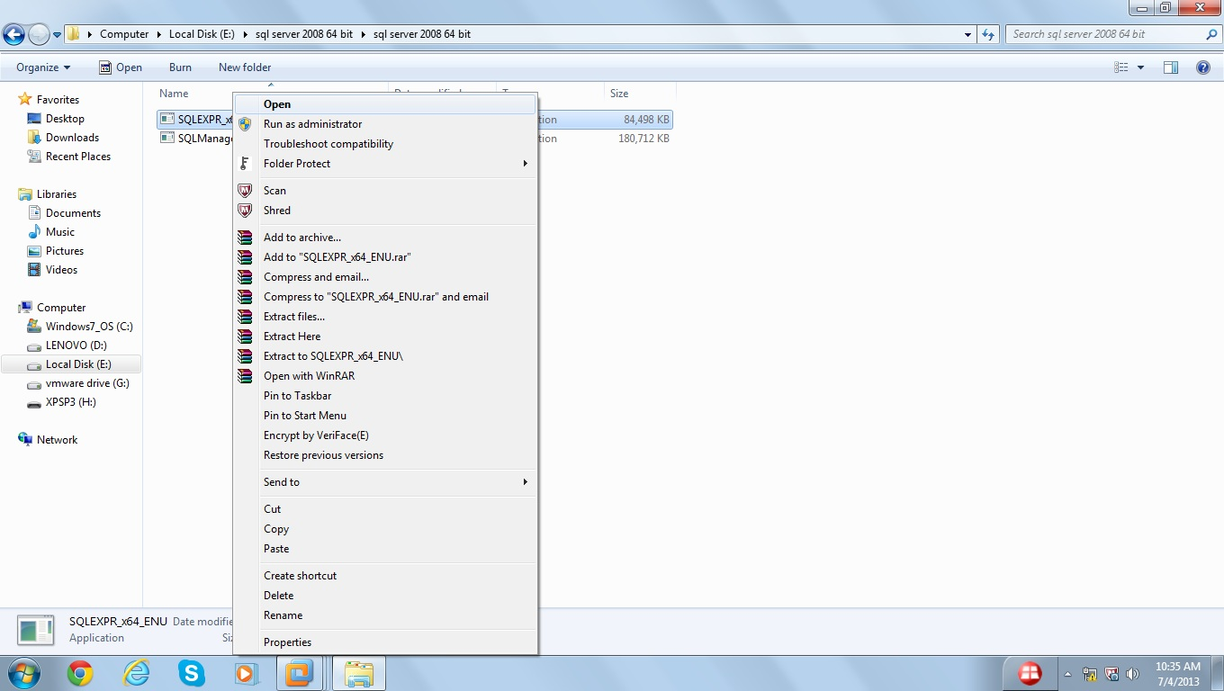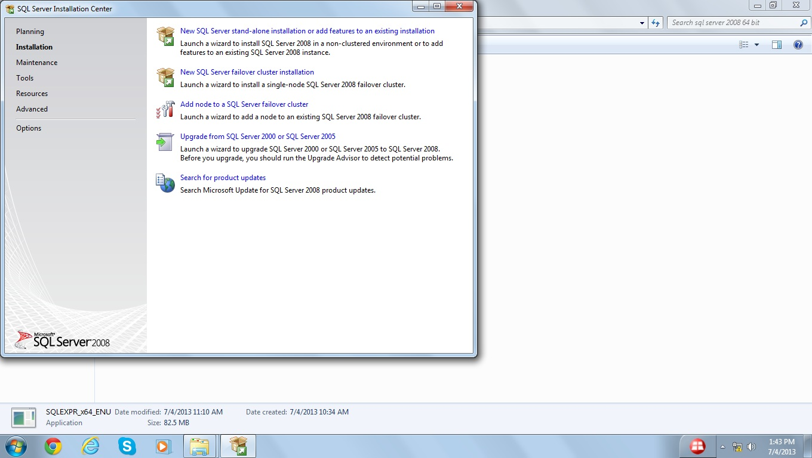

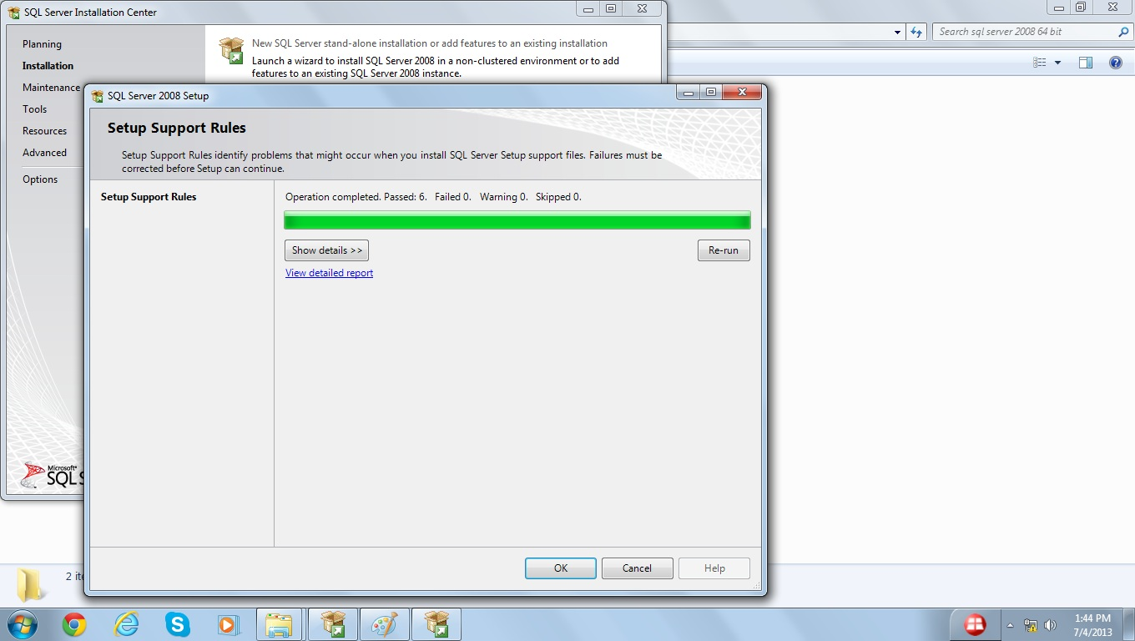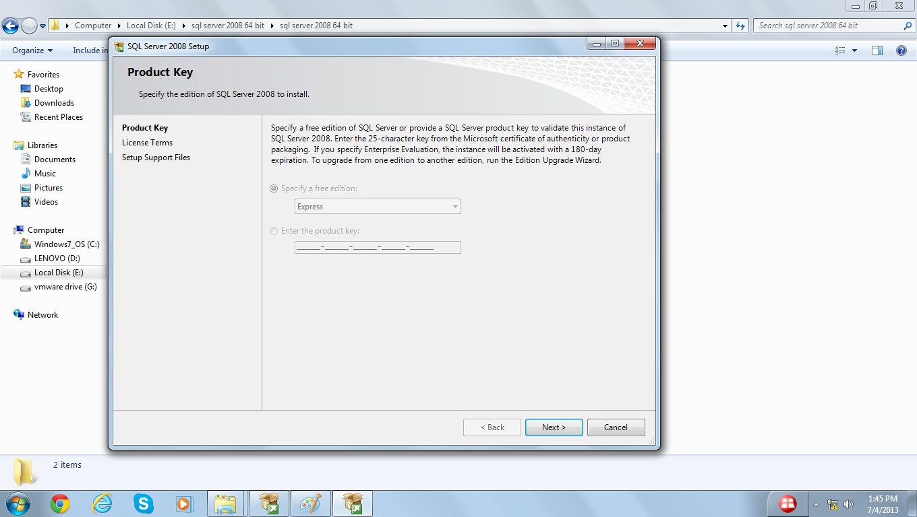

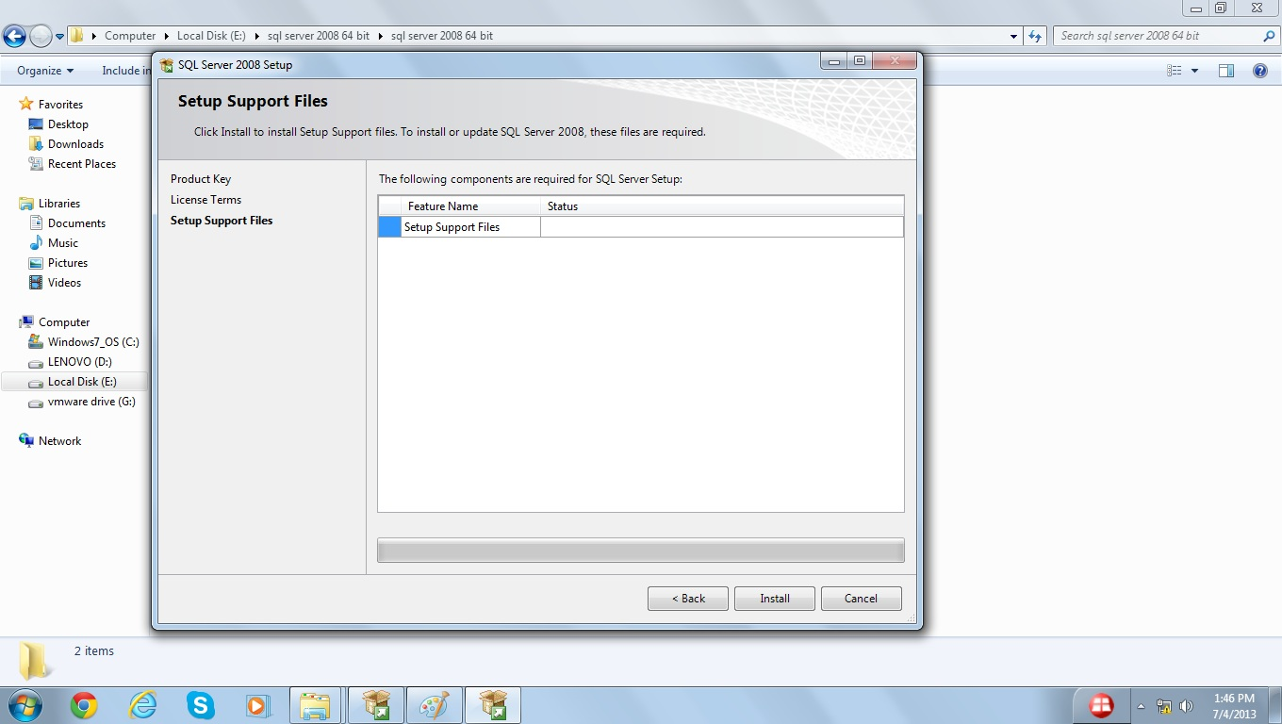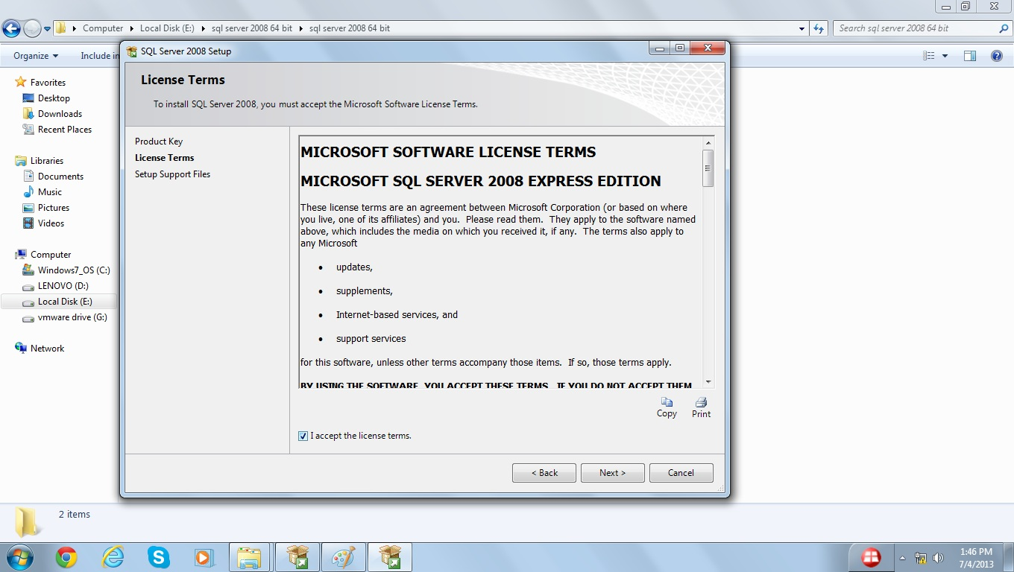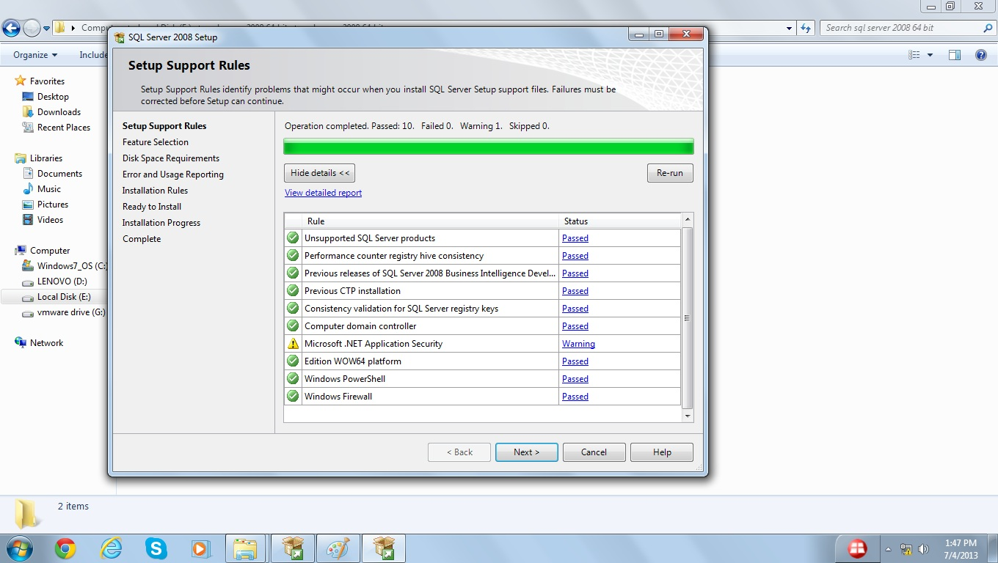

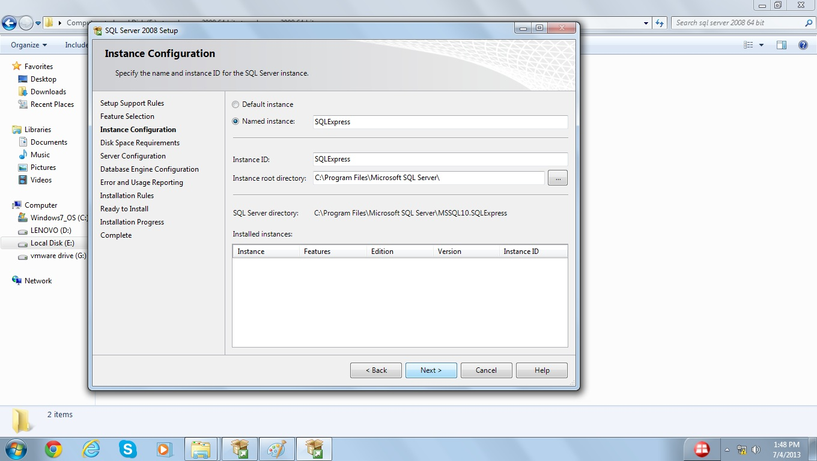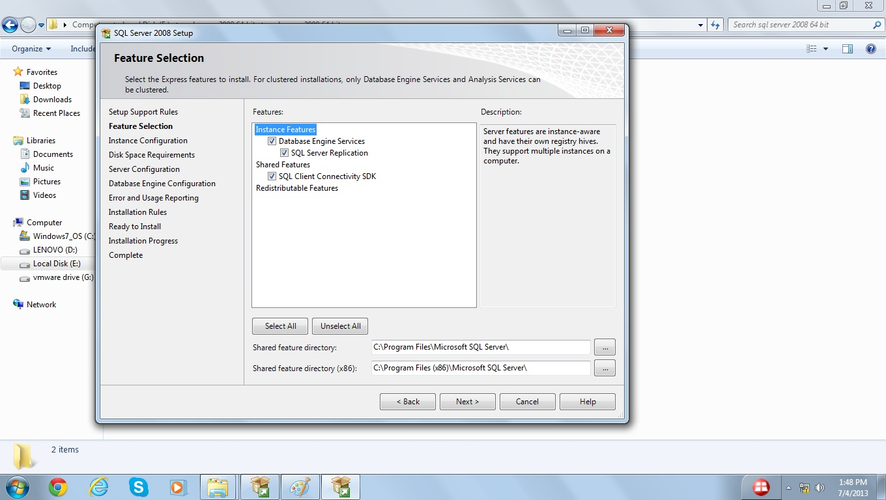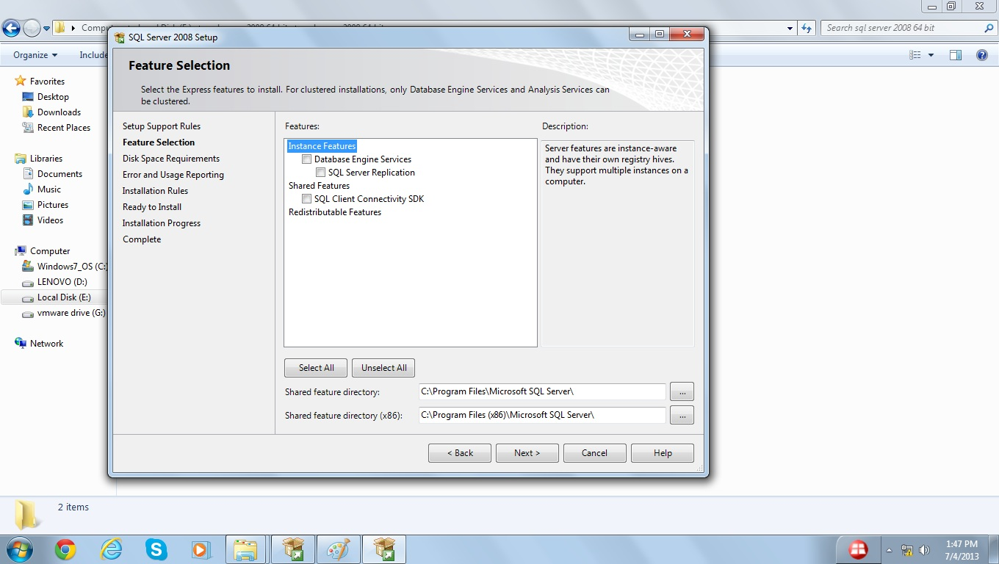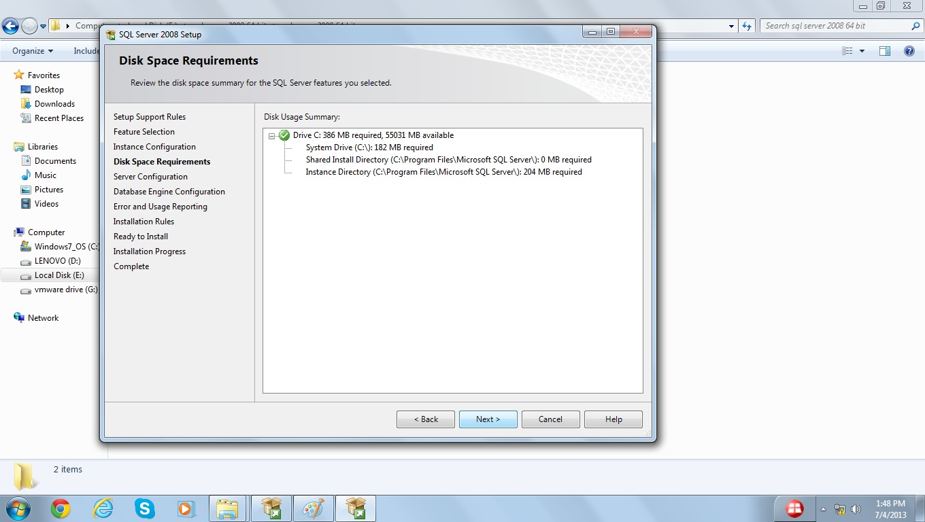

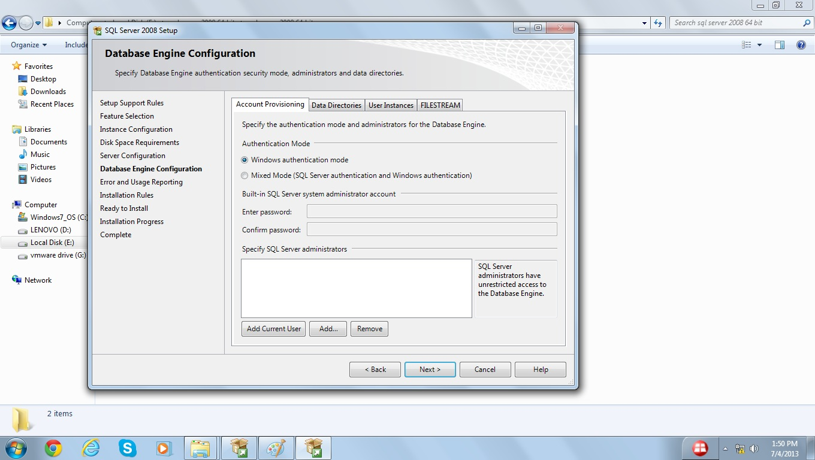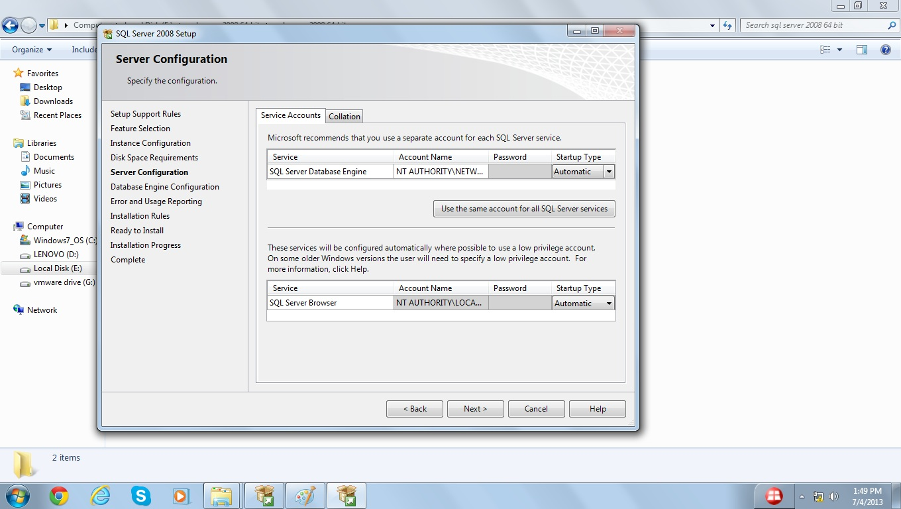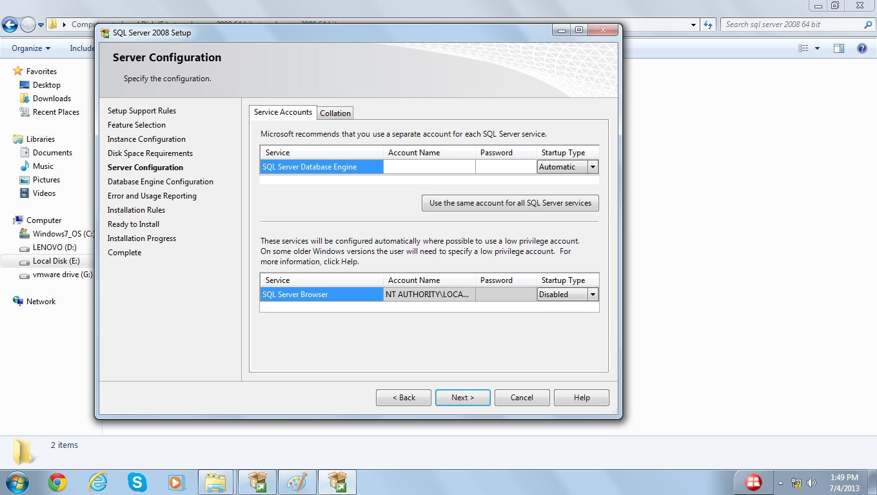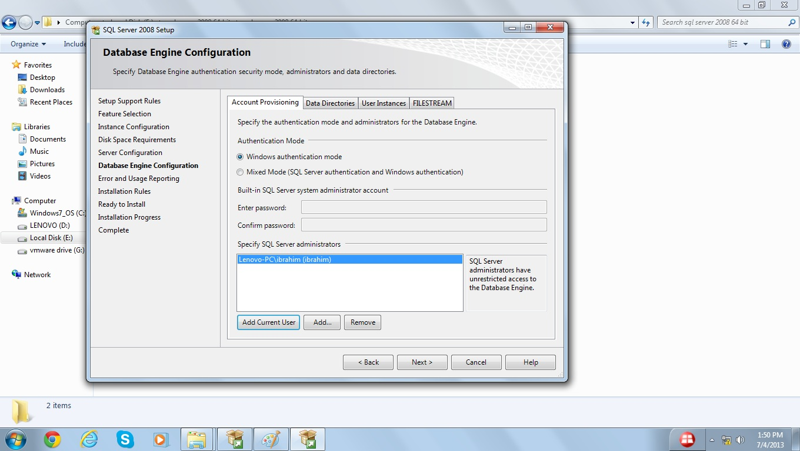

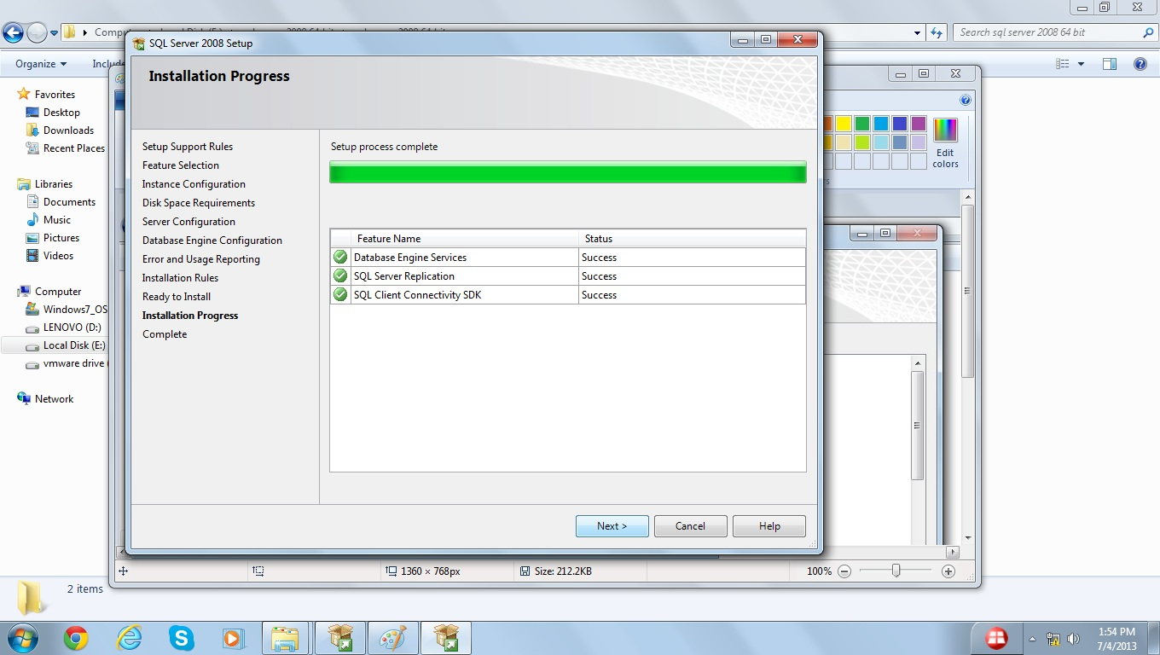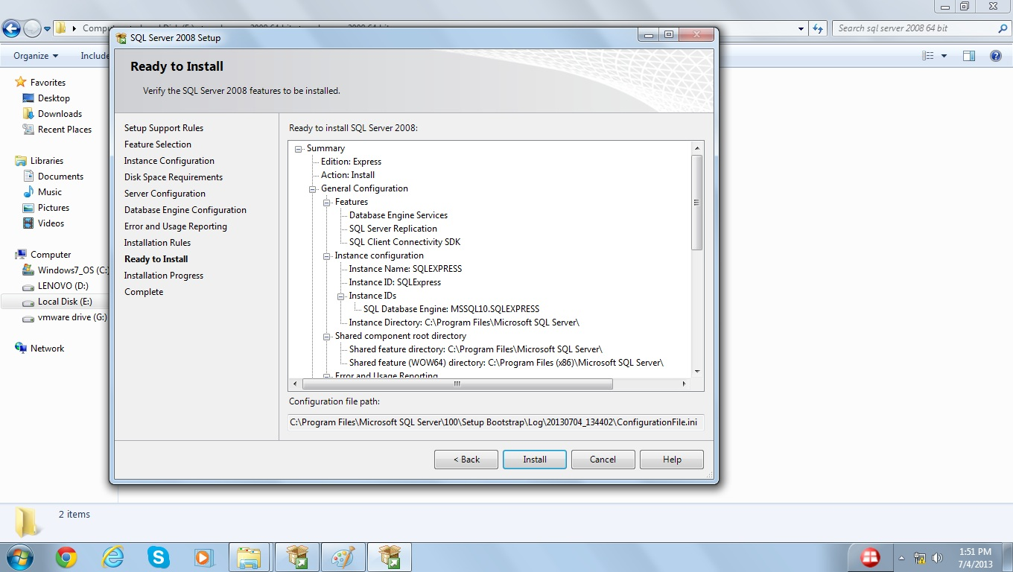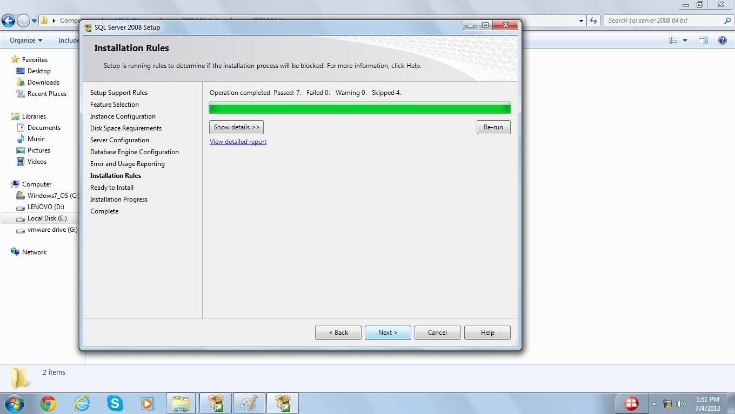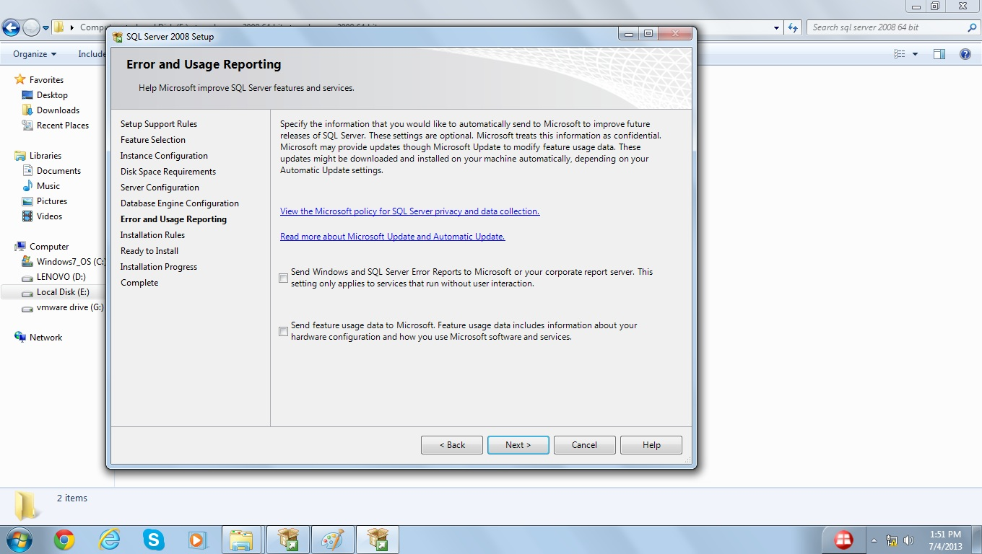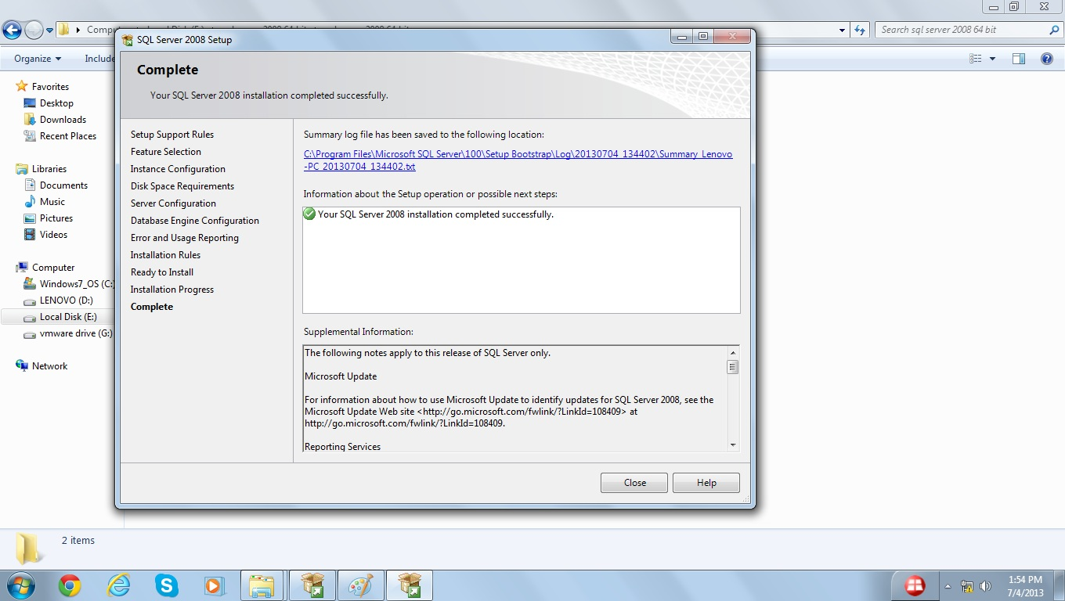

Mechanism to Conduct Lab:
Lab will be conducted via Google Meet / Zoom.

Lab 2
Lab Title: Context Level DFD (Data Flow Diagram)

Problem Statement

Lemon Soda Service
“Thela”, lemon soda offering company has decided to take orders online. By using this online system customer can place the order and view receipt generated by system. Order is prepared/processed and sent to delivery man. The delivery man will deliver order and receive payment form the customer. After receiving payment, the delivery man can update status in the system as payment received.
Identify the External Entities and processes from the above scenario and draw:
- Context Level DFD
- Level 0 DFD

Solution:

Context Level DFD

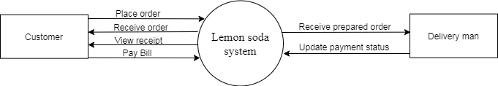

Level 0 DFD

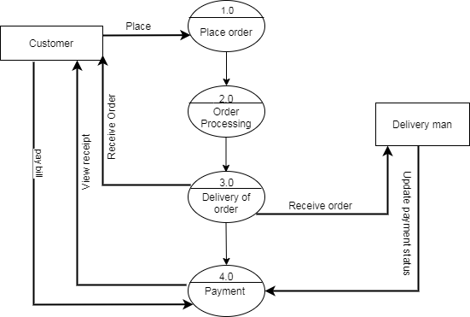

Mechanism to Conduct Lab:
Lab will be conducted via Google Meet / Zoom.

Lab 3
Lab Title: Entity Relationship Diagram

Problem Statement

Lemon Soda Service
“Thela”, lemon soda offering company has decided to take orders online. Customer places the order online and at the time of delivery pays the bill. Order is prepared and delivered by the delivery man to the customer. Customer pays the bill to the delivery man.
Perform the following tasks on the given scenario:
- Identify Entities.
- Identify the attributes of the entities.
- Identify the relationships between the entities.
- Draw the Entity Relationship diagram from the information extracted in first three tasks.

Solution:
ERD:
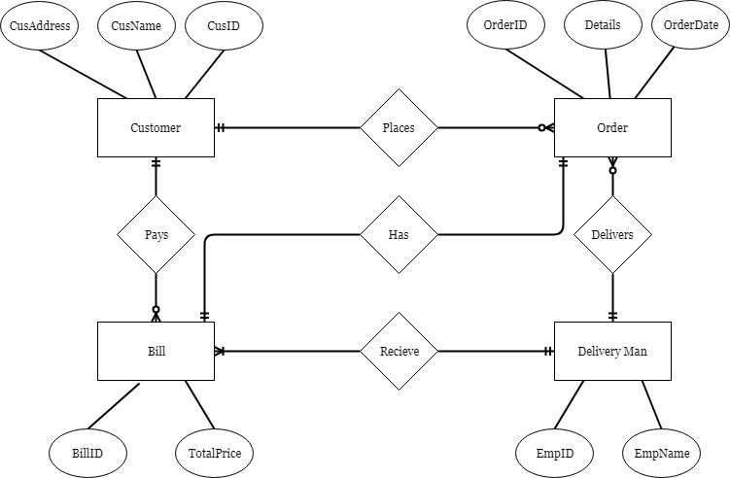

Mechanism to Conduct Lab: Lab will be conducted via Google Meet / Zoom.

Lab 4
Lab Title: Super type and subtype in the ERD (Entity Relationship Diagram)

Problem Statement
Lemon Soda Service
“Thela”, lemon soda offering company has decided to take orders online. Customer places the order online and at the time of delivery pays the bill. Order is prepared and delivered by the delivery man to the customer. Customer pays the bill to the delivery man.
Customer and Delivery man both are the person. Introduce the concept of super type and subtype in the ERD drawn in Lab 3.

Solution
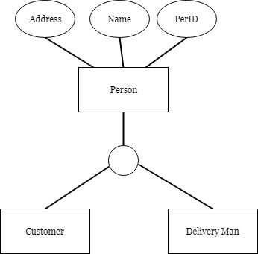

Mechanism to Conduct Lab:
Lab will be conducted via Google Meet / Zoom.
Lab 5
Lab Title: Relational Database

Problem Statement
Consider the following relation scheme of “Candidate” entity in the domain of Election Commission of Pakistan (ECP).
Candidate Scheme = (CandName : Text , Constituency : Text , Age : Number , Qualification : Text )
You are required to perform the following task:
- A database relation having 4 tuples.
- Represent the database relation created in 1 as a two dimensional structure called Table.

Solution:
- Database relation:
Candidate = { (Rana Maqsood, NA-45, 40, BA) , (Sohail Khan, NA-16, 55, MA), (Shiraz Hussain Dar, NA-21, 37, MS) ,(Asad Ullah, NA-65, 35, M.Sc) }
- Table
CandName | Constituency | Age | Qualification
Rana Maqsood | NA-45 | 40 | BA
Sohail Khan | NA-16 | 55 | MA
Shiraz Hussain Dar | NA-21 | 37 | MS
Asad Ullah | NA-65 | 35 | M.Sc

Mechanism to Conduct Lab:
Lab will be conducted via Google Meet / Zoom.
Lab 6
Lab Title: ERD to RDM

Problem Statement
You are required to transform the following ERD (Entity Relationship Diagram) to Relational Data model using the transforming/mapping rules taught in the video lectures and handouts. You also have to show the primary keys and foreign keys.
ERD:
Solution:
Customer (CusID, CusName, CusAddress)
Order (OrderID, OrderDate, Details, CusID, EmpID)
Bill (BillID, TotalPrice, CusID, EmpD, OrderID)
DeliveryMan (EmpID, EmpName)

Mechanism to Conduct Lab: Lab will be conducted via Google Meet / Zoom.
Lab 7
Lab Title: Relational Algebra Operations

Problem Statement
Consider the following two relations:
Employee 1:
EmpName | Designation | Age | Salary
Khalid Khan | Director | 38 | 65000
Tariq Khan | Supervisor | 27 | 16000
Sadiq Amin | Account Officer | 28 | 28000
Shabir Hussain | Manager | 35 | 40000
Tanveer Ahmad | Admin Officer | 30 | 30000
Farooq | Clerk | 25 | 12000

Employee 2:
EmpName | Designation | Age | Salary
Farukh | Lecturer | 27 | 25000
Waqar Shah | Assistant Professor | 35 | 45000
Jibran Akhtar | Network Admin | 28 | 27000
Yasir Zaib | HR Manager | 35 | 42000

You are required to perform the following relational algebra operations.
- σ Salary >20000 (Employee 1)
- σ Salary <40000 (Employee 2)
- Π EmpName, Salary (Employee 2)
- Employee 1 U Employee 2
Solution:
1
EmpName | Designation | Age | Salary
Khalid Khan | Director | 38 | 65000
Sadiq Amin | Account Officer | 28 | 28000
Shabir Hussain | Manager | 35 | 40000
Tanveer Ahmad | Admin Officer | 30 | 30000

2
EmpName | Designation | Age | Salary
Farukh | Lecturer | 27 | 25000
Jibran Akhtar | Network Adin | 28 | 27000

3
EmpName | Salary
Farukh | 25000
Waqar Shah | 45000
Jibran Akhtar | 27000
Yasir Zaib | 42000

4
EmpName | Designation | Age | Salary
Khalid Khan | Director | 38 | 65000
Tariq Khan | Supervisor | 27 | 16000
Sadiq Amin | Account Officer | 28 | 28000
Shabir Hussain | Manager | 35 | 40000
Tanveer Ahmad | Admin Officer | 30 | 30000
Farooq | Clerk | 25 | 12000
Farukh | Lecturer | 27 | 25000
Waqar Shah | Assistant Professor | 35 | 45000
Jibran Akhtar | Network Adin | 28 | 27000
Yasir Zaib | HR Manager | 35 | 42000

Mechanism to Conduct Lab:
Lab will be conducted via Google Meet / Zoom.

Lab 8
Lab Title: Normalization (2NF)

Problem Statement
You have studied the concept of normalization (and different normal forms) in this course. Following relation is already in First Normal Form. You are required to convert it into Second Normal Form using the techniques you have studied so far.
EmpID | Name | DeptName | salary | CourseTitle | DateCompleted
101 | Latif | Marketing | 35000 | Advertising | 15/03/2010
101 | Latif | Marketing | 35000 | Survey | 15/03/2010
103 | Mukhtar | Accounting | 47000 | MS Excel | 10/06/2011
104 | Zafar | IT | 57000 | Oracle | 18/04/2009
104 | Zafar | IT | 57000 | Java | 14/09/2007
106 | Nasir | Finance | 70000 | Investment | 19/08/2008
107 | Ali | Marketing | 35000 | Advertising | 15/03/2010
107 | Ali | Marketing | 35000 | ecommerce | 21/05/2012

The above relation contains different redundancies. The relation can be expressed in a shorthand notation as follows:
EMPLOYEE (EmpID, Name, DeptName, Salary, CourseTitle, DateCompleted)
The above relation contains a composite primary key of EmpID and CourseTitle. The functional dependencies in this relation are as follows:
EmpID Name, DeptName, Salary
EmpID, CourseTitle DateCompleted

Solution:

All the partially dependent attributes are removed and placed in another relation when a relation is converted from 1NF to 2NF. The decomposition must satisfy one of the following conditions.
A relation will be in 2NF if any of the following conditions are met:
- The primary key consists of only one attribute
- No non-key attributes exist in the relation
- Every non-key attribute is functionally dependent on the full set of primary key attributes.
The EMPLOYEE relation can be divided into two relations EMPLOYEE and COURSE as follows:
EMPLOYEE (EmpID, Name, DeptName, Salary)
EmpID | Name | DeptName | Salary
101 | Latif | Marketing | 35000
103 | Mukhtar | Accounting | 47000
104 | Zafar | IT | 57000
106 | Nasir | Finance | 70000
107 | Ali | Marketing | 35000

COURSE: (EmpID, CourseTitle, DateCompleted)

EmpID | CourseTitle | DateCompleted
101 | Advertising | 15/03/2010
101 | Survey | 15/03/2010
103 | MS Excel | 10/06/2011
104 | Oracle | 18/04/2009
104 | Java | 14/09/2007
106 | Investment | 19/08/2008
107 | Advertising | 15/03/2010
107 | ecommerce | 21/05/2012

The primary key in EMPLOYEE relation consists of only one attribute. It satisfies the first condition. The attribute DateCompleted in COURSE relation is fully functionally depends on whole composite key. It satisfies the third condition. It means that both relations are in second normal forms.

Mechanism to Conduct Lab:
Lab will be conducted via Google Meet / Zoom.

Lab 9
Lab Title: Normalization (3NF)
Problem Statement
Following relation is already in Second Normal Form. You are required to convert it into Third Normal Form using the techniques you have studied so far.
CustomerID | Name | SalesMan | Region
11 | Hamza | Khalid | South
21 | Shoaib | Umair | West
31 | Shahbaz | khalid | South
44 | Salman | Zulfiqar | East
51 | Rizwan | Umair | West
61 | Farooq | Uzair | North

The relation can be expressed in a shorthand notation as follows:
SALES (CustomerID, Name, SalesMan, Region)
The attribute CustomerID is used as primary key. Each salesman is assigned a unique region. The above relation contains the following functional dependencies:
CustomerID Name, SalesMan
SalesMan Region
The above relation is in 2NF because the primary key consists of single attribute. A transitive dependency exists in the relation. The Region (a non-key attribute) is dependent on another non-key attribute (SalesMan) and SalesMan is functionally dependent on CustomerID. It means that region is transitively dependent on CustomerID.

Solution:
Transitive dependency exists if a non-key attribute depends on any other non-key attribute.
The transitive dependency can be removed by decomposing the above relation into two relations as follows:
CustomerID | Name | SalesMan
11 | Hamza | Khalid
21 | Shoaib | Umair
31 | Shahbaz | khalid
44 | Salman | Zulfiqar
51 | Rizwan | Umair
61 | farooq | Uzair

SALES (CustomerID, Name, SalesMan)
SalesMan | Region
Khalid | South
Umair | West
Zulfiqar | East
Uzair | North

SALESMAN (SalesMan, Region)

Both relations are now in 3NF. There is no transitive dependency in these relations.
The determinant attribute in transitive dependency becomes the primary key in SALESMAN relation.

Mechanism to Conduct Lab:
Lab will be conducted via Google Meet / Zoom.
Lab 10
Lab Title: SQL Queries (Create and Insert)
Problem Statement

Consider the following tables:
Teacher:
TeacherID | Name | Office | Phone | Salary | Email
T001 | Dr. Najma Waheed | F001 | 9125 | 150000 | najma@uni.edu.pk
T002 | Dr. Nouman Masood | F003 | 5291 | 175000 | nouman@uni.edu.pk
T003 | Dr. Farhana Khan | F001 | 9222 | 125000 | farhana@uni.edu.pk

Class:

ClassID | CourseCode | DayofWeek | StartTime | EndTime | Venue
A001 | CS403 | Monday | 09:00 AM | 10:00 AM | A Block
B002 | CS301 | Tuesday | 09:00 AM | 10:00 AM | B Block
C003 | CS201 | Monday | 10:30 AM | 12:00 PM | C Block

Consider the above given tables and perform the following Tasks;
- Write the query to create the above tables in SQL Server.
- Insert the records given in the above tables.

Solution:

CREATE TABLE Teacher(
TeacherID varchar(5) primary key,
Name varchar(30),
Office vrchar(10),
Phone smallint,
Salary int,
Email varchar(20)

);

CREATE TABLE Class(
ClassID varchar(5) primary key,
CourseCode varchar(10),
DayofWeek varchar(10),
StartTime time,
EndTime time,
Venue varchar(10)
);

INSERT INTO Teacher(TeacherID, Name, Office, Phone, Salary, Email)
VALUES('T001','Dr. Najma Waheed','F001', 9125, 150000,'najma@uni.edu.pk');

INSERT INTO Teacher(TeacherID, Name,Office, Phone, Salary, Email)
VALUES('T002','Dr. Nouman Masood','F003', 5291, 175000,'nouman@uni.edu.pk');

INSERT INTO Teacher(TeacherID, Name, Office, Phone, Salary, Email)
VALUES('T003','Dr. Farhana Khan','F001', 9222, 125000,'farhana@uni.edu.pk');

INSERT INTO class(ClassID, CourseCode, DayofWeek, StartTime, EndTime, Venue)
VALUES('A001','CS403','Monday', '09:00:00', '10:00:00','A Block');

INSERT INTO class(ClassID, CourseCode, DayofWeek, StartTime, EndTime, Venue)
VALUES('B002','CS301','Tuesday', '09:00:00', '10:00:00','B Block');

INSERT INTO class(ClassID, CourseCode, DayofWeek, StartTime, EndTime, Venue)
VALUES('C003','CS201','Monday', '10:30:00', '12:00:00','C Block');

Mechanism to Conduct Lab:
Lab will be conducted via Google Meet / Zoom.

Lab 11
Lab Title: SQL Queries

Problem Statement
Given are the tables of Teacher and Class:
TeacherID | Name | Office | Phone | Email
T001 | Dr. Najma Waheed | F001 | 9125 | najma@uni.edu.pk
T002 | Dr. Nouman Masood | F003 | NULL | nayyer@uni.edu.pk
T003 | Dr. Farhana Khan | F002 | 9222 | farhana@uni.edu.pk
T004 | Dr. Tayyaba Ali | F005 | 9325 | tayyaba@uni.edu.pk
T005 | Mr. Nouman Ahmad | F006 | 9145 | nouman@uni.edu.pk
T006 | Mr. Waqass Raheem | F004 | NULL | waqas@uni.edu.pk

ClassID | CourseCode | DayofWeek | TimeStart | TimeEnd | Venue | TeacherID
A001 | CS403 | Monday | 09:00 AM | 10:00 AM | A Block | T003
B002 | CS301 | Tuesday | 09:00 AM | 10:00 AM | B Block | T005
A001 | CS304 | Tuesday | 14:00 PM | 15:00 PM | A Block | T002
C003 | CS201 | Monday | 10:30 AM | 12:00 PM | C Block | T006
C003 | CS301 | Friday | 12:00 PM | 13:00 PM | C Block | T005
B005 | CS403 | Friday | 12:30 PM | 14:00 PM | B Block | T003

Consider the above given tables and perform the following Tasks;

- Display all the records of the class whose start time is between 09:00 and 12:00
- Retrieve the details of teachers with first name Dr.
- On which days classes of CS403 are scheduled at 09:00 AM?
- List down the Subjects which are taught in B Block.
- Select the course code from Class table, avoiding the duplicate values.
- Display all the records of the class whose start time is 09:00 or 12:00 and end time is less than 14:00
Solution:
1:

Select *
From Classes
Where StartTime Between '09:00' and '12:00'

2:
Select * from Teacher
Where Name Like 'Dr.%'

3:
Select DayofWeek
From Classes
Where CourseCode='CS403' AND StartTime='09:00'

4:
Select CourseCode
From Classes
Where Venue='B Block'

5:
Select distinct CourseCode
From Classes

6:
Select *
From Classes
Where (StartTime='09:00' OR StartTime='12:00') AND EndTime<'14:00'

Mechanism to Conduct Lab:
Lab will be conducted via Google Meet / Zoom.

Lab 12
Lab Title: SQL Queries (Select, Group By and Having clause)

Problem Statement
Teacher:
TeacherID | Name | Office | Phone | Salary | Email
T001 | Dr. Najma Waheed | F001 | 9125 | 150000 | najma@uni.edu.pk
T002 | Dr. Nouman Masood | F003 | 5291 | 175000 | nouman@uni.edu.pk
T003 | Dr. Farhana Khan | F001 | 9222 | 125000 | farhana@uni.edu.pk

Class:

ClassID | CourseCode | DayofWeek | StartTime | EndTime | Venue
A001 | CS403 | Monday | 09:00 AM | 10:00 AM | A Block
B002 | CS301 | Tuesday | 09:00 AM | 10:00 AM | B Block
C003 | CS201 | Monday | 10:30 AM | 12:00 PM | C Block

Consider the above given tables and perform the following Tasks;
- Count the number of teachers
- Count the unique courses from Classes table
- List subject-wise classes according to earlier end time.
- Calculate the average salary of the teachers sitting in the same office with office not null.

Solution:

1:
Select count(*) from Teacher;

2:
Select count(distinct CourseCode) As All_Courses
from Class;

3:
Select Min(EndTime) As Late_Classes
from Class
GROUP BY CourseCode;

4:

Select AVG(Salary)
From Teacher
GROUP BY Office
Having Office IS NOT NULL;

Mechanism to Conduct Lab:
Lab will be conducted via Google Meet / Zoom.

Lab 13
Lab Title: Joins
Problem Statement

TeacherID | Name | Office | Phone | Email
T001 | Dr. Najma Waheed | F001 | 9125 | najma@uni.edu.pk
T002 | Dr. Nouman Masood | F003 | NULL | nayyer@uni.edu.pk
T003 | Dr. Farhana Khan | F002 | 9222 | farhana@uni.edu.pk
T004 | Dr. Tayyaba Ali | F005 | 9325 | tayyaba@uni.edu.pk
T005 | Mr. Nouman Ahmad | F006 | 9145 | nouman@uni.edu.pk
T006 | Mr. Waqass Raheem | F004 | NULL | waqas@uni.edu.pk

ClassID | CourseCode | DayofWeek | TimeStart | TimeEnd | Venue | TeacherID
A001 | CS403 | Monday | 09:00 AM | 10:00 AM | A Block | T003
B002 | CS301 | Tuesday | 09:00 AM | 10:00 AM | B Block | T005
C003 | CS201 | Tuesday | 14:00 PM | 15:00 PM | A Block | T002
D004 | CS501 | Monday | 10:30 AM | 12:00 PM | C Block | T006
E005 | CS401 | Friday | 12:00 PM | 13:00 PM | C Block | T005
F006 | CS402 | Friday | 12:30 PM | 14:00 PM | B Block | T003

Consider the above given tables and apply the following types of joins:
- Inner join
- Full Outer join
- Right Outer join
- Left Outer join

Solution:

- SELECT * FROM Teacher INNER JOIN Class ON Teacher.TeacherID=Class.TeacherID;
- SELECT * FROM Teacher FULL OUTER JOIN Class ON Teacher.TeacherID=Class.TeacherID;
- SELECT * FROM Teacher RIGHT OUTER JOIN Class ON Teacher.TeacherID=Class.TeacherID;
- SELECT * FROM Teacher LEFT OUTER JOIN Class ON Teacher.TeacherID=Class.TeacherID;

Mechanism to Conduct Lab:
Lab will be conducted via Google Meet / Zoom.

Lab 14
Lab Title: Indexes

Problem Statement

Consider the following table:
TEACHER:

TeacherID | Name | Office | Phone | Email
T001 | Dr. Najma Waheed | F001 | 9125 | najma@uni.edu.pk
T002 | Dr. Nouman Masood | F003 | NULL | nayyer@uni.edu.pk
T003 | Dr. Farhana Khan | F002 | 9222 | farhana@uni.edu.pk
T004 | Dr. Tayyaba Ali | F005 | 9325 | tayyaba@uni.edu.pk
T005 | Mr. Nouman Ahmad | F006 | 9145 | nouman@uni.edu.pk
T006 | Mr. Waqass Raheem | F004 | NULL | waqas@uni.edu.pk

You are required to perform the following tasks:
- Write SQL query to create a UNIQUE INDEX on the “TeacherID” column of the given table in Descending order.
- Write SQL query to create a UNIQUE INDEX on the “Name” and “Office” columns of the given table in ascending order.

Solution:
1
CREATE UNIQUE INDEX Teacher_Index1
On TEACHER (TeacherID DESC);
2
CREATE UNIQUE INDEX Teacher_Index2
On TEACHER (Name, Office ASC);

Mechanism to Conduct Lab:
Lab will be conducted via Google Meet / Zoom.

Lab 15
Lab Title: Views

Problem Statement
Class:
ClassID | CourseCode | DayofWeek | TimeStart | TimeEnd | Venue | TeacherID
A001 | CS403 | Monday | 09:00 AM | 10:00 AM | A Block | T003
B002 | CS301 | Tuesday | 09:00 AM | 10:00 AM | B Block | T005
C003 | CS201 | Tuesday | 14:00 PM | 15:00 PM | A Block | T002
D004 | CS501 | Monday | 10:30 AM | 12:00 PM | C Block | T006
E005 | CS401 | Friday | 12:00 PM | 13:00 PM | C Block | T005
F006 | CS402 | Friday | 12:30 PM | 14:00 PM | B Block | T003

You are required to write an SQL query to create a “View” on this table having ClassID, CourseCode and Venue columns. Furthermore, the view would have information for only those classes conducted in the “A Block” venue.
Solution:
CREATE VIEW Class_View AS
SELECT ClassID, CourseCode, Venue
FROM CLASS
WHERE Venue='A Block';

Mechanism to Conduct Lab:
Lab will be conducted via Google Meet / Zoom.

Lab 16
Lab Title: Views (Continued)

Problem Statement
Consider the following table:
Products:
ProductName | Purchase_Price | Sale_Price | Stock_Qty
Bread | 20 | 25 | 50
French Pastry | 17 | 25 | 35
Slice | 20 | 25 | 20
Large Cake | 50 | 60 | 30
Dairy Cream Cake | 40 | 47 | 40
Pastry | 10 | 15 | 70
Biscuit | 15 | 20 | 45
Rolls | 25 | 30 | 65
Lays Chips (small size) | 18 | 20 | 115
Lays Chips (Medium size) | 47 | 50 | 100
Lays Chips (Large size) | 92 | 100 | 80

You are required to write an SQL query to create a “View” on this table having ProductName, Sale_Price and Stock_Qty columns. Furthermore, the view would have information for only those products having Sale price greater than the average sale price in the given table.

Solution:

CREATE VIEW Product_View AS
SELECT ProductName, Sale_Price, Stock_Qty
FROM Products
WHERE Sale_Price > (SELECT AVG(Sale_Price) FROM Products) ;

Mechanism to Conduct Lab:
Lab will be conducted via Google Meet / Zoom.

